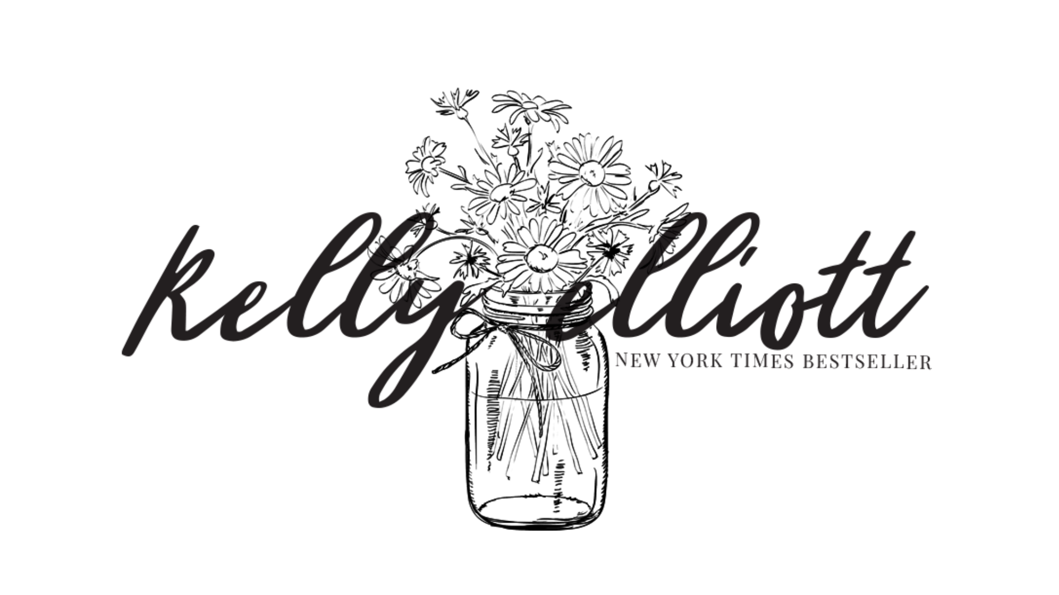

Reading List

Wanted Series
Wanted

Saved

Faithful

Believe

Cherished

A Forever Love

The Wanted Short Stories

All They Wanted

Desired

Love Wanted in Texas (Wanted Spin off series)
Without You

Saving You

Holding You

Finding You

Chasing You

Loving You

Broken Series
Broken

Broken Dreams

Broken Promises

Broken Love

Journey of Love Series
Unconditional Love

Undeniable Love

Unforgettable Love

Speed Series
Ignite

Adrenaline

With Me Series
Stay with Me

Only with Me

Boston Love Series
Searching for Harmony

Fighting for Love

Cowboys and Angels Series
Lost Love

Love Profound

Tempting Love

Love Again

Blind Love

This Love

Reckless Love

Austin Singles Series
Seduce Me

Entice Me

Adore Me

Southern Bride Series
Love at First Sight

Delicate Promises

Divided Interests

Lucky in Love

Feels Like Home (September 2020)

Take Me Away (December 2020)

Fool for You (April 2021)

The Right Moves (August 2021)

Meet Me in Montana
Never Enough

Always Enough

Good Enough (October 2020)

Strong Enough (February 2021)

Stand Alones
The Journey Home

Who We Were

The Playbook

Made for You

Predestined Hearts

Play Me

Dangerous Temptations

